**Problem 1**

Logb(n) = ϴ(log2(n))

f(n) <= Cg(n)

logb(n) <= log2(n)

Graph:

Where b=5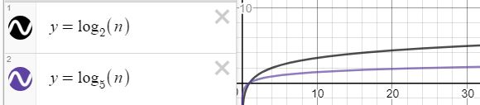

X axis = independent variable = horizontal

Y axis = dependent variable = vertical

Post induction, we will have:

1<=f(n)/g(n)

1<= log(2)/log(b)

Thus, b will need to be 2 or larger to make this equation true.

**Problem 2**

f $\sum_{i=1}^{n}{}$  $i^{15}$ = ϴ($n^{16})$

f(n) <= Cg(n)

f $\sum_{i=1}^{n}{}$  $i^{15}$ <= $n^{16}$

$1^{15}$ <= $1^{16}$

$1^{}$ <= $1^{}$

True

$3^{15}$ + $2^{15}$ + $1^{15}$ <= $3^{16}$

14,381,676 <= 43,046,721

Also true

Post induction, we will have

1<=f(n)/g(n)

1<=i^16 / f $\sum_{i=1}^{n}{}$ $i^{15}$

With this, we can say that i will be true for all positive numbers, because for all positive numbers, i^16 will always be equal or larger than i^15, and all the previous summations

**Problem 3**

**Part A**

n! = ϴ($n^{n})$

f(n) <= Cg(n)

$n!$ <= $n^{n}$

EX1:

5! <= $5^{5}$

120<=3125

EX2:

1! <= $1^{1}$

1 <= 1

post-induction , we will have

1<=f(n)/g(n)

1<=n^n / n!

For all positive numbers, this will be a true statement, because of squaring, vs multiplying by lesser values.

**Part B**

$n^{n}$ =/= ϴ($n!$)

f(n) <= Cg(n)

$n^{n}$ <= $n!$

3125 <= 120

False

post-induction , we will have

1<=f(n)/g(n)

1<=n! / n^n

For most positive numbers outside of 1, this is a false scenario

**Problem 4**

Fibonacci Sequence:

1,1,2,3,4,8,13,21,34,55,89,144

The differences between these sets grows over time. The differences between the current number, and the next number are:

0,1,1,2,3,5,8,13,21,34,35

This difference grows to be larger and larger over time making this exponential.

**Problem 5**

**Semi-Log plot:**

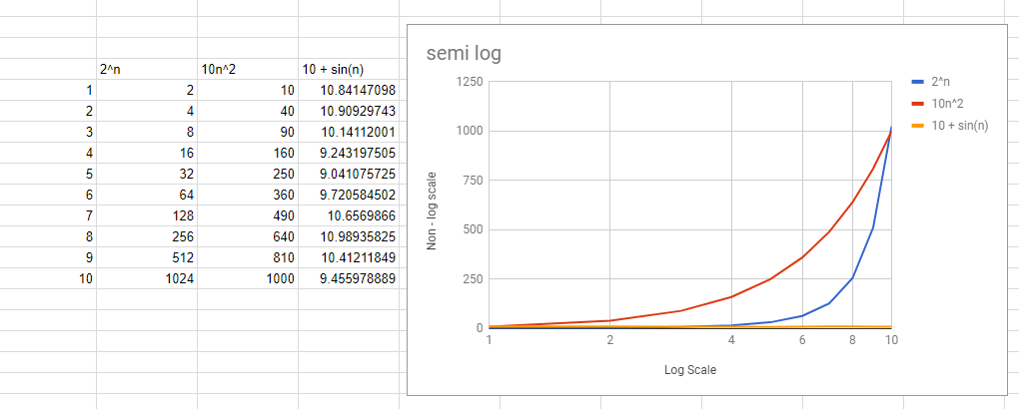

X axis = independent variable = horizontal = logarithmic

Y axis = dependent variable = vertical

**Log-log plot:**

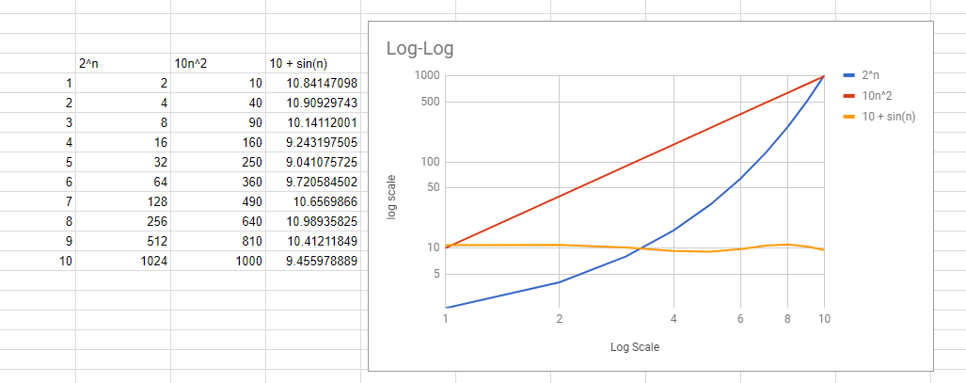

X axis = independent variable = horizontal= logarithmic

Y axis = dependent variable = vertical= logarithmic

**Problem 6**

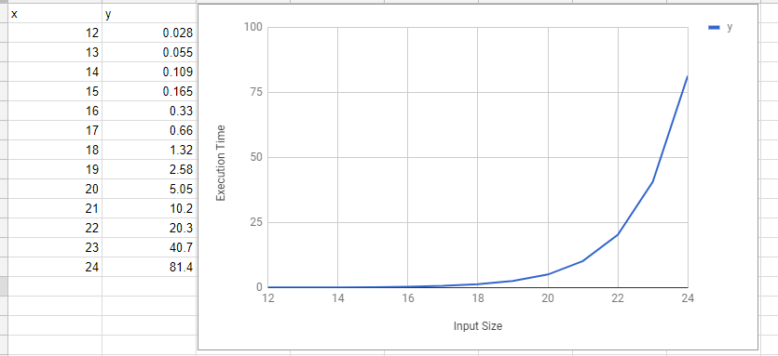

I would say that a line graph or a scatter graph would be best to represent the data, it will display that as the x value increases, the y value dramatically increases at an exponential rate, because of large differences between segments, and no indication that it curves up, I will say that this is an exponential graph.

**Problem 7**

the following algorithm is computing the total size of variable B, it will decrement B and increment A to get the real size of B.

Effectively saying that B = A, where a is F(B) or, for equation’s sake: n = n

**Problem 8**

after value 6, the data appears to adhere to a rough Î˜(2n) form, but I would not say that is the best representation of this data set.

predicted value ~ 161775922

based on the Equation generated at https://mycurvefit.com/

y = 232618599999.99997 + (1532.275 - 232618599999.99997)/(1 + (x/57.79748)^11.08697)

**Problem 9**

I believe that this data from prog-a is able to be reasonably written in the form (ϴ(N^K), while it may be difficult to derive an exact exponential value to represent this, it is an estimate.

estimated values:

Ka higher end = 1.2645, lower end = .55813

This appears to grow over time, which makes it more difficult to settle on a solution, so i've given a rough y= 32768^(32768*.000038589) for the higher end.

Kb

Kb higher end = 1.2530, lower end = .78138

This appears to grow over time, which makes it more difficult to settle on a solution,so i've given a rough y= 32768^(32768*.000038238) for the higher end.

for which one would be asymptotically faster, I would have to say Kb, because over time it grows slower, but it has a slower initial start.